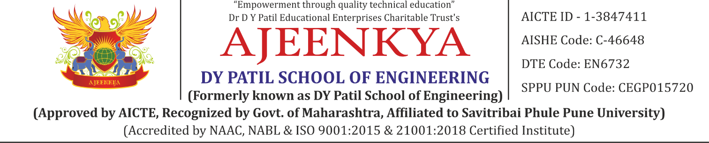
DEPARTMENT OF COMPUTER ENGINEERING
Class: BE A.C.Year : 2025-2026 Sem: II
Subject Name: Laboratory Practice V
List of Experiment
Sr.No | Name of Experiment
1a | Design and implement Parallel Breadth First Search based on existing algorithms using OpenMP. Use a Tree or an undirected graph for BFS.
1b | Design and implement Parallel Depth First Search based on existing algorithms using OpenMP. Use a Tree or an undirected graph for DFS
2a | Write a program to implement Parallel Bubble Sort. Use existing algorithms and measure the performance of sequential and parallel algorithms
2b | Write a program to implement Parallel Merge Sort. Use existing algorithms and measure the performance of sequential and parallel algorithm
3 | Implement Min, Max, Sum and Average operations using Parallel Reduction
4a | Write a CUDA Program for Addition of two large vectors
4b | Write a Program for Matrix Multiplication using CUDA C
6 | Linear regression by using Deep Neural network: Implement Boston housing price. prediction problem by Linear regression using Deep Neural network. Use Boston House price prediction dataset.
7a | Binary classification using Deep Neural Networks Example: Classify movie reviews into positive" reviews and "negative" reviews, just based on the text content of the reviews.Use IMDB dataset
7b | Multiclass classification using Deep Neural Networks: Example: Use the OCR letter recognition dataset https://archive.ics.uci.edu/ml/datasets/letter+recognition
8 | Use MNIST Fashion Dataset and create a classifier to classify fashion clothing into categories

